



Implementation of the Basic Concepts of File Handling in Python
LAB MANUAL

Disclaimer: The content is curated from online/offline resources and used for educational purpose only
Implementation of the Basic Concepts of File Handling in Python

Objective:
- Learn how to open, close, read, write, append, and delete files in Python using functions like open(), close(), read(), write(), and os.remove().

Problem Statement:
In this problem, you will explore how to use Python’s built-in file handling functions to create, read, write, append, and delete files. The goal is to understand how to work with files effectively, manage input and output operations, and handle exceptions that may occur during file operations.

Equipment Required:
- Install VS Code - https://code.visualstudio.com/download
- Download Python Installer File - https://www.python.org/downloads/
Prerequisites:
- Basic Computer Skills - Anyone starting to learn computer programming needs basic computer skills.
- Basics of control statements

Procedure:
Task 1: To Opening a file in write mode ('w')
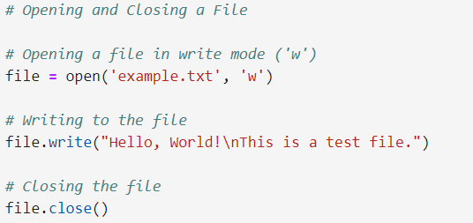
Task 2: Opening a file in read mode ('r')
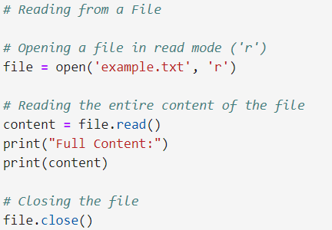
Output:
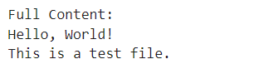
Task 3: Opening the file again to read line by line
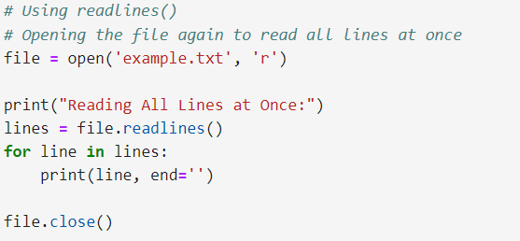
Output:
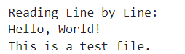
Task 4: Opening the file again to read all lines at once
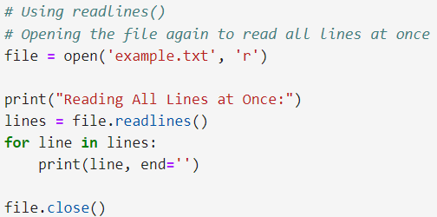
Output:
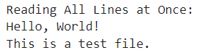
Task 5: Opening a file in append mode ('a')
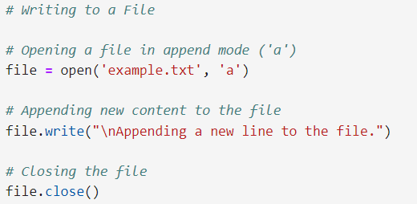
Task 6: Using with statement to automatically close the file
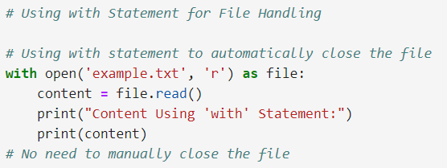
Task 7: File Pointer Management
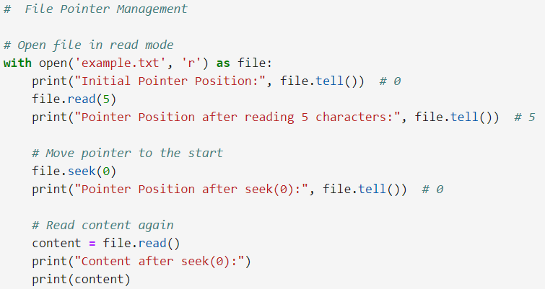
Output:
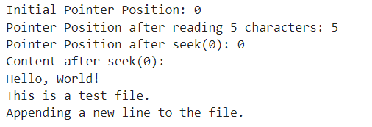
Task 8: Checking File Existence with csv file
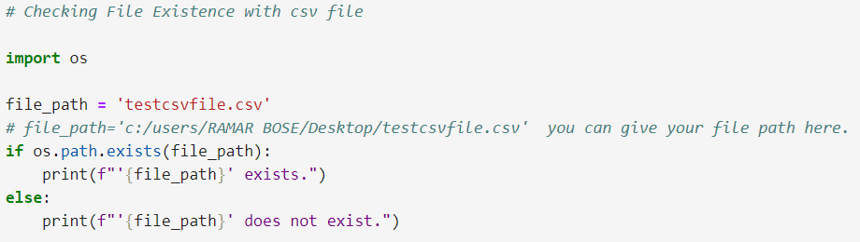
Output:
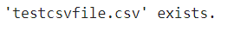
Task 9: Handling File Exceptions
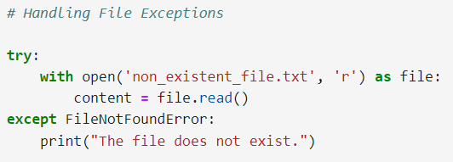
Output:
